**INTEGRATION TESTING:**

Integration testing is the second level of the software testing process after unit testing. In this testing, units or individual components of the software are tested in a group. The focus of the integration testing level is to expose defects at the time of interaction between integrated components or units.

**Testing All Functionalities:**

Sunny testing reports

Test_case_01-ADMIN DETAILS:-

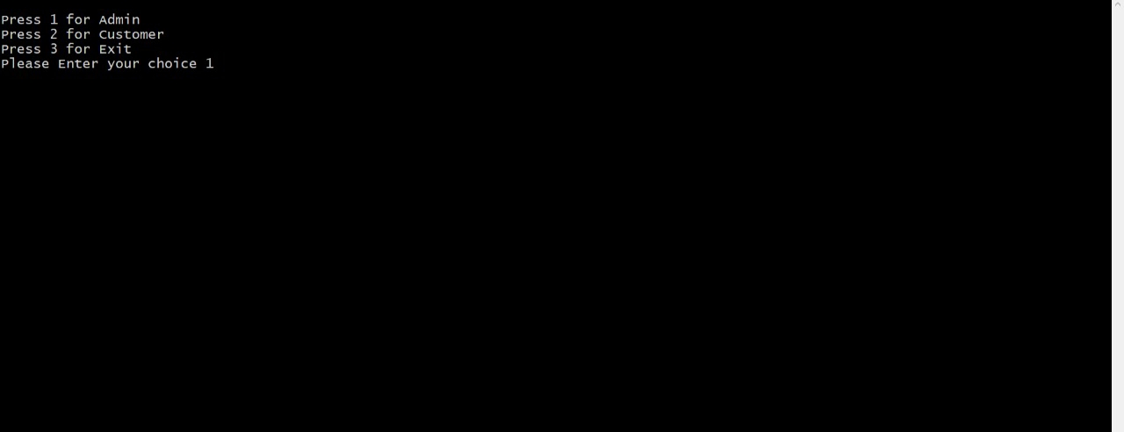

Test­­­­­­­­­­­_case_02:-registering

By entering the user name and password we can register into the admin page. By login in to the admin page we can see the details related to the menu list to add items, display, delete, update the items.

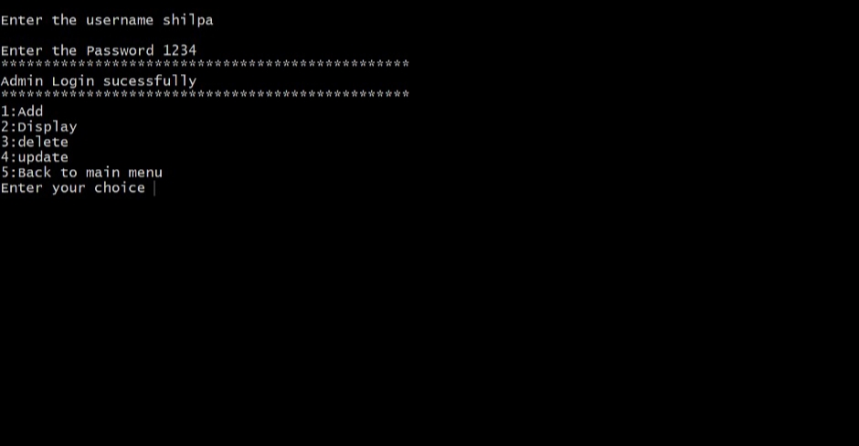

Test_case 03-Menu:-

In the menu list the admin can add the new items into the snacks center. And then the user is able to see the items and able to place the order.

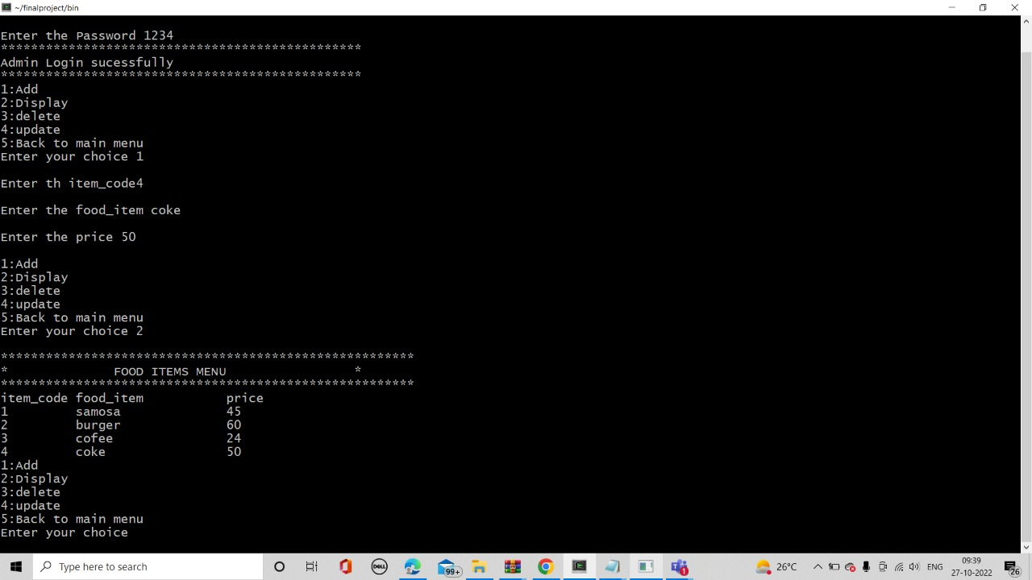

TEST_CASE_04-DELETE THE ITEMS:-

The admin can be able to delete the items in the menu list. When the admin will deleted the items in the menu list the user is not able to see the deleted items. The user is able to place the order by seeing the current items.

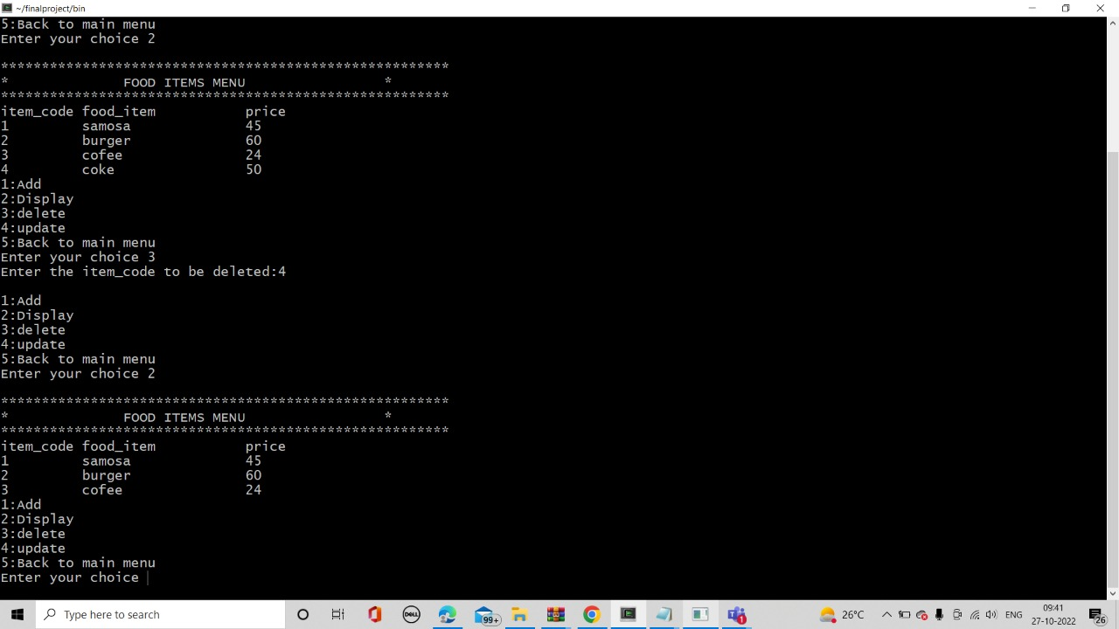

TEST_CASE_06-UPDATE THE ITEMS:-

In the Admin panel, the admin can do the changes in the menu list like prices, items replace and item code in an item. Changes can be done by the admin only.

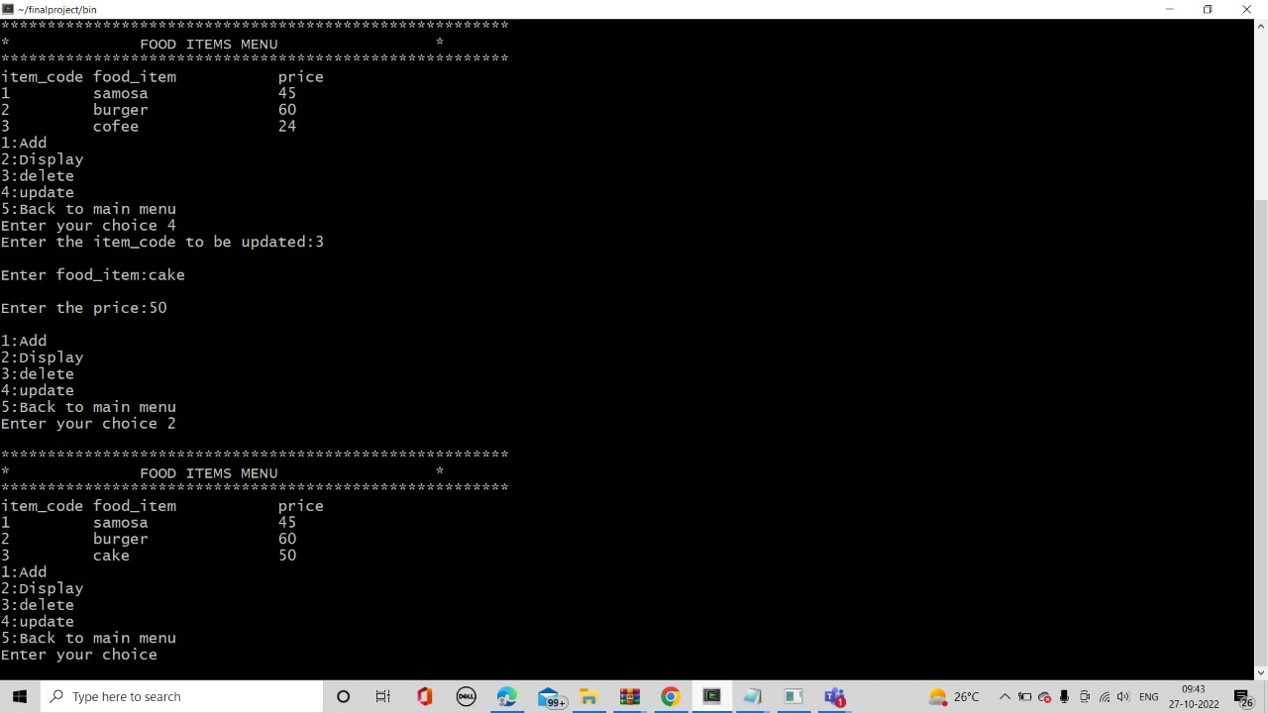

Test_case_07_Customer details:-

Customer giving the details in the in the admin panel that is username and the mobile number and the distance is less than 10 kms. After entering the item code and quantity the bill is appeared and the order is confirmed.

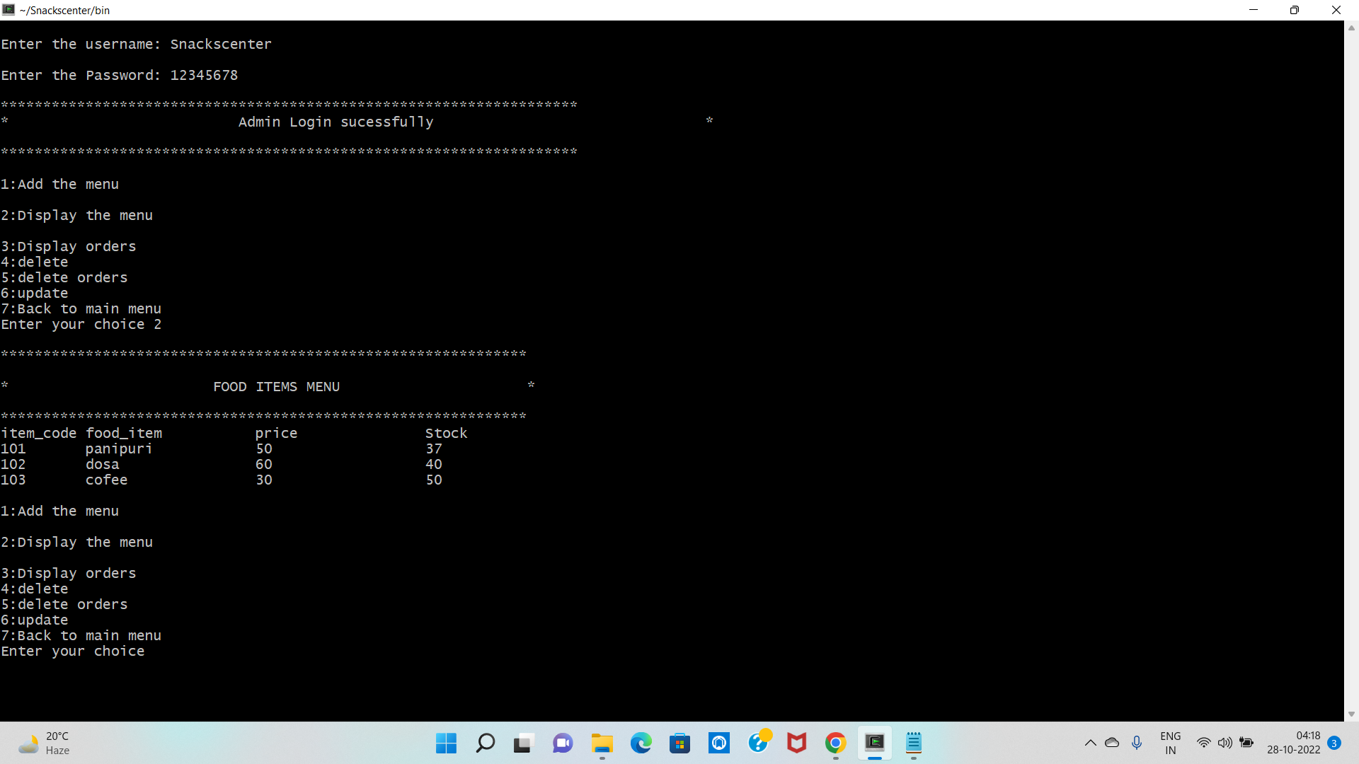

RAINY_TEST_CASES-

Test_case_01:-

Invalid detail of admin:-

The details of the admin will be given wrong the it is considered as the invalid details.

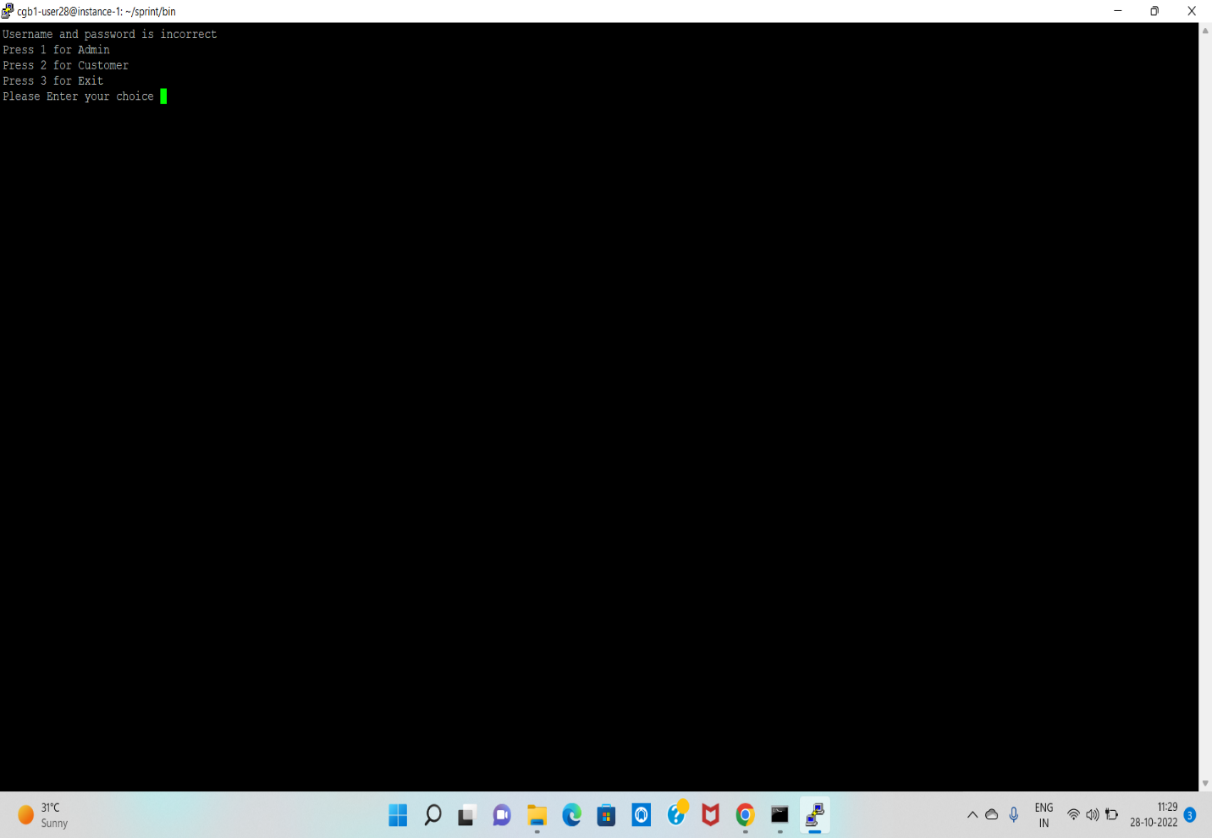

Test_case_02:-

User is not beyond the limit. Then it can not be able to move further process. 